**HW09MenuToAddAnimals**

15 CRUZ PANTOJA DARLING MICAELA

Version 01

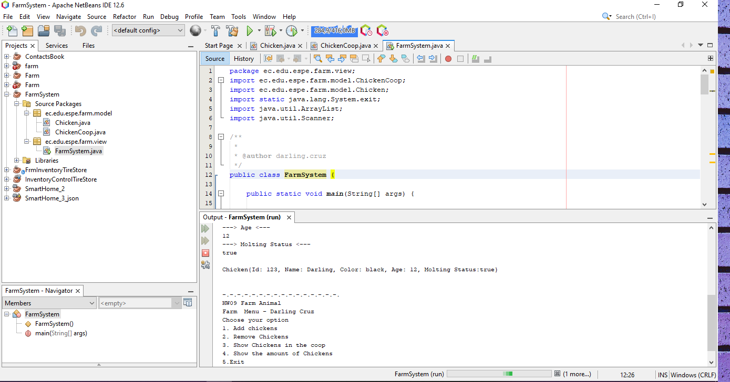

Version 02

